­­

Serverless Authentication Using AWS Cognito Usage of the AWS Cognito service

“Amazon Cognito” is a powerful authentication and authorization service managed by Amazon Web Services (AWS) and is often combined with Amazon API Gateway and AWS-Lambda to build secure serverless web services ,When building a complex web service such as a serverless application, sooner or later you must deal with permission control.  
It provides authentication, authorization, and user management for your web and mobile apps. Your users can sign in directly with a user name and password, or through a third party such as Facebook, Amazon, Google or Apple. The two main components of Amazon Cognito are user pools and identity pools. User pools are user directories that provide sign-up and sign-in options for your app users. Identity pools enable you to grant your users access to other AWS services. You can use identity pools and user pools separately or together.

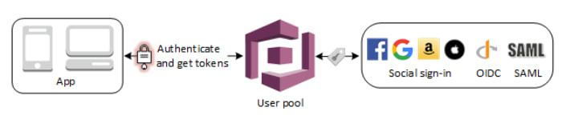

Flow chart for Authentication using User pool

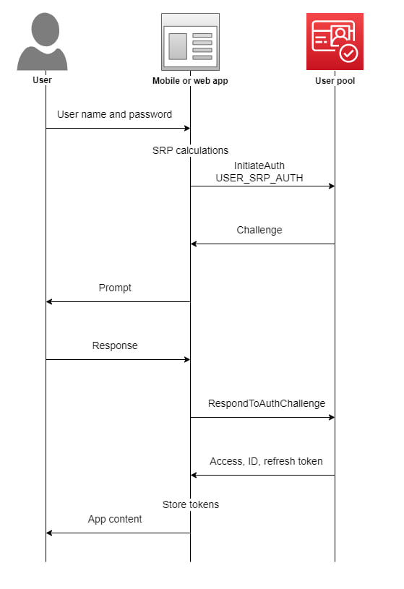

Features:-

A user pool and Identity pools support anonymous guest users . With these your users can sign in to your web or mobile app through Amazon Cognito, or federate through a third-party identity provider (IdP). Whether your users sign in directly or through a third party, all members of the user pool have a directory profile that you can access through an SDK.

* Sign-up and sign-in services.
* A built-in, customizable web UI to sign in users.
* Social sign-in with Facebook, Google, Login with Amazon, and Sign in with Apple, and through SAML and OIDC identity providers from your user pool.
* User directory management and user profiles.
* Security features such as multi-factor authentication (MFA), checks for compromised credentials, account takeover protection, and phone and email verification.
* Customized workflows and user migration through AWS Lambda triggers.’
* Amazon Cognito user pools
* Social sign-in with Facebook, Google, Login with Amazon, and Sign in with Apple
* OpenID Connect (OIDC) providers
* SAML identity providers
* Developer authenticated identities

To save user profile information, your identity pool needs to be integrated with a user pool.

Services:-

Some of the services used are :

Amazon S3 , AWS Identity And Access Management[IAM] , AWS Lambda ,

Amazon Cognito , Amazon DynamoDB, API Gateway

1. Use IAM roles with Amazon Cognito. Some of the services used

2.Service limits and quotas for Amazon Cognito user pools requests and resources.

3. Once the Amazon Cognito credentials provider is initialized and refreshed, you can pass it directly to the initializer for an AWS client.

4.Before you use IAM to manage access to Cognito, learn what IAM features are available to use with Cognito

5.AWS **services** are in scope of a specific compliance program.

6.You can monitor Amazon Cognito user pools using Amazon CloudWatch or using Service Quotas. CloudWatch collects raw data and processes it into readable.

7.You can enable your users to sign-in with a user pool, and then access AWS **services** using an identity pool.

8.You can view and manage your Amazon Cognito user pools quotas from a central location with Service Quotas

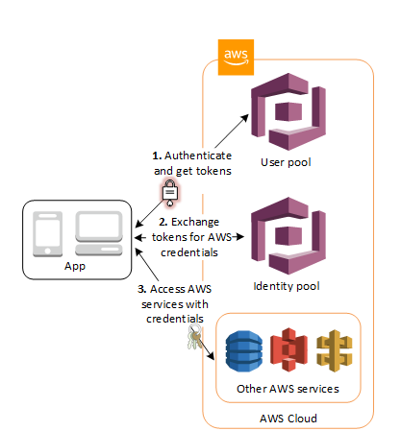

* In the first step your app user signs in through a user pool and receives user pool tokens after a successful authentication.
* Next, your app exchanges the user pool tokens for AWS credentials through an identity pool.
* Finally, your app user can then use those AWS credentials to access other AWS services such as Amazon S3 or DynamoDB.

Few screenshots during the work procedure

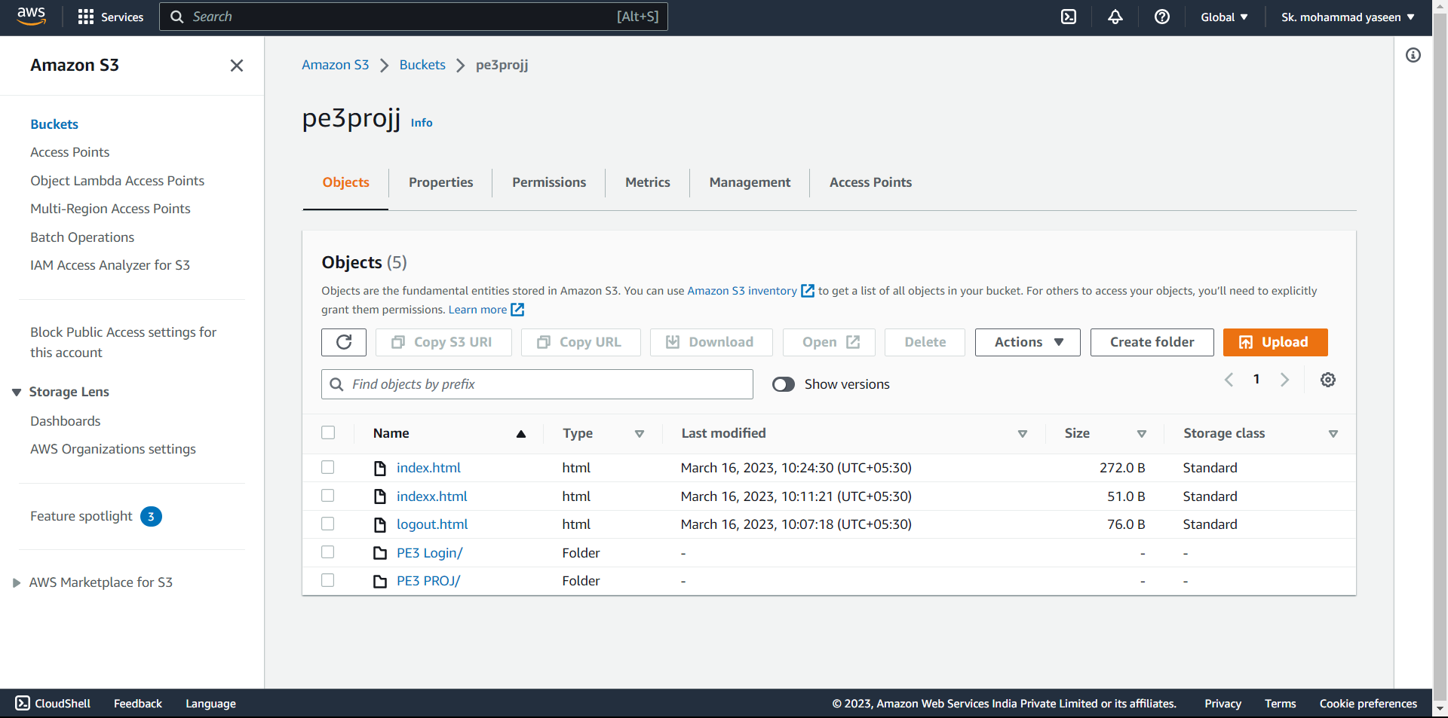

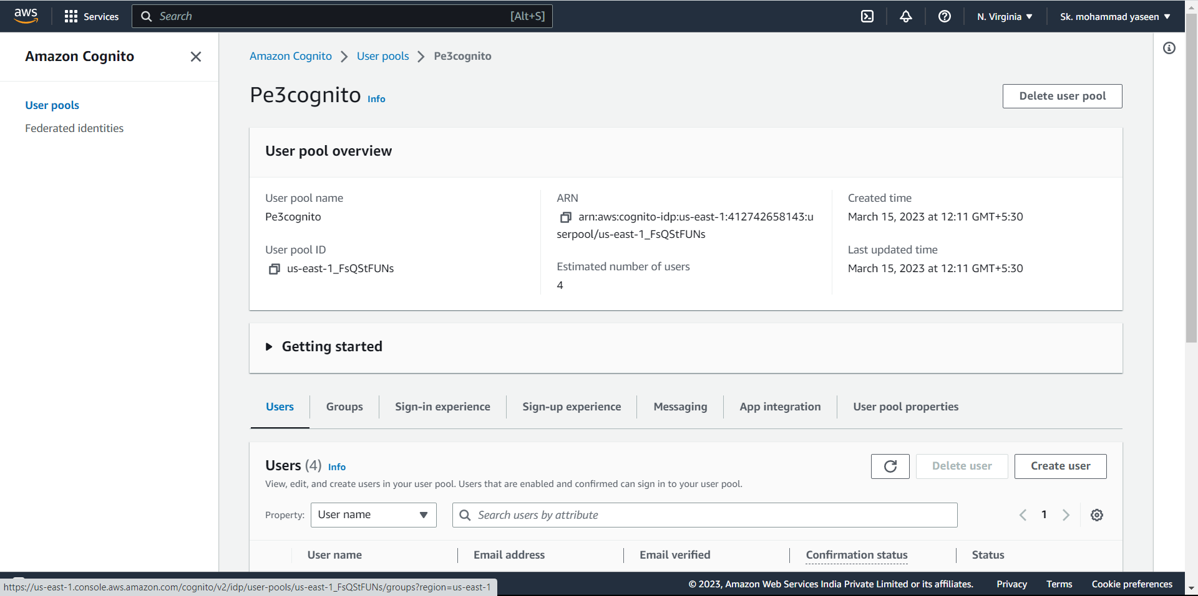

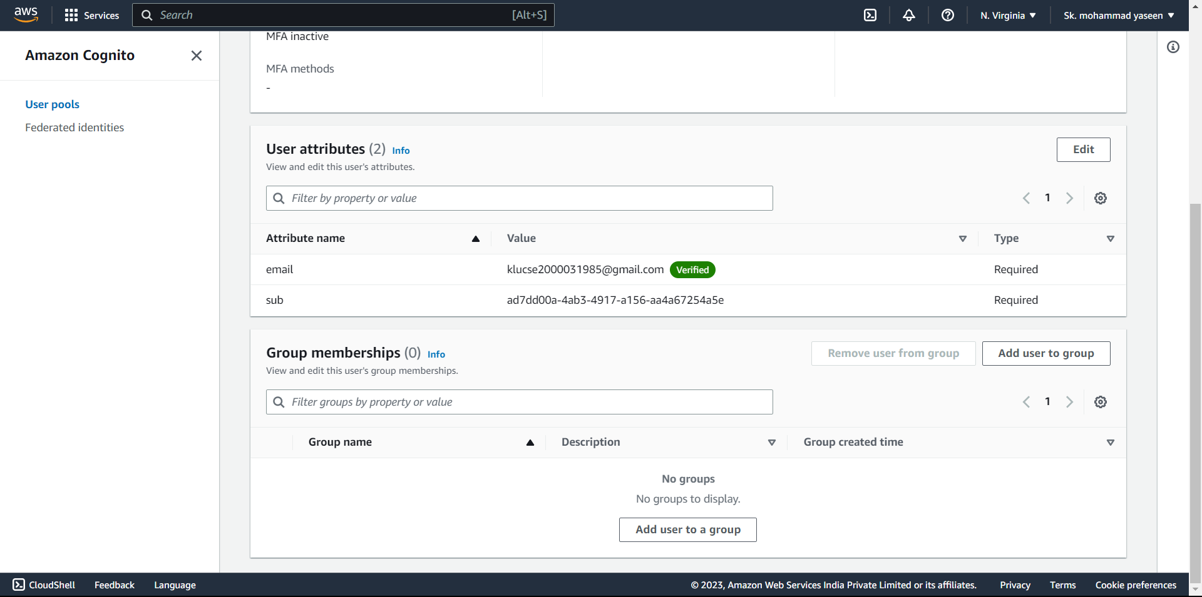

Outputs of my project



